NA Boys Soccer 2020
Spirit Wear

Delivery with 3 weeks of order!
Sale dates: Thursday, September 3rd – Tuesday, September 8th. Please use provided order form. Checks only payable to Soccer Source. Return your order form and payment to Alice Beckett-Rumberger or directly to Soccer Source (9600 Perry Highway).
****Contact Alice Beckett-Rumberger (412-400-5222) with any questions!

These items can be personalized! $2 for name or number and $3 for name and number.

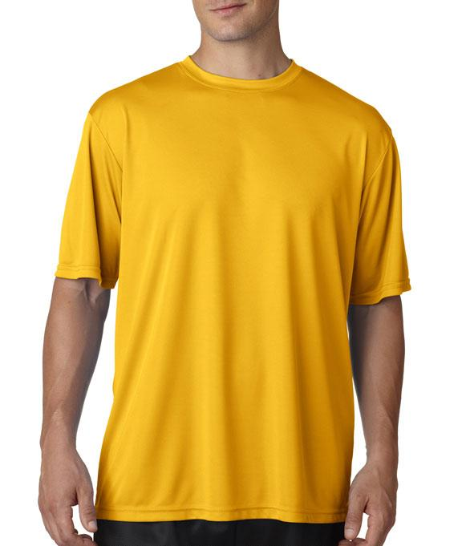
Short Sleeve dri-Fit A4 with NA logo:
Avail in Youth M-YXL and
AS thru A2XL
$15
black, graphite or gold

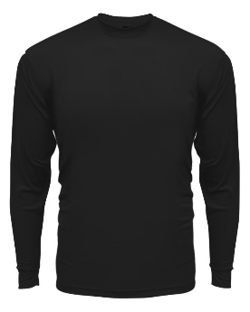
Long Sleeve dri-fit A4 with NA logo:
Avail in YM-YXL and
AS – A2XL
$18
black, graphite or gold

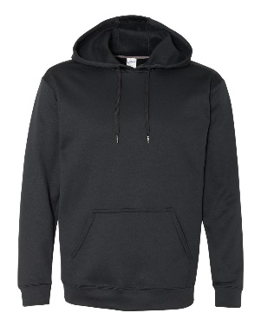
Gildan Sport-Tech Hoody with NA logo:
Avail in black YM – YXL and AS – A2XL for $35
graphite avail in YM and YL only and AS – A2XL for $35 (No YXL option available)

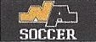
All spirit wear will feature this logo!

